**WEEK – 3**

**Spring Core and Maven**

**Exercise 1: Configuring a Basic Spring Application**

**File Name : pom.xml**

<dependencies>

<!-- Spring Core Dependency -->

<dependency>

<groupId>org.springframework</groupId>

<artifactId>spring-context</artifactId>

<version>5.3.36</version>

</dependency>

</dependencies>

**File Name : applicationContext.xml**

<?xml version="1.0" encoding="UTF-8"?>

<beans xmlns="http://www.springframework.org/schema/beans"

xmlns:xsi="http://www.w3.org/2001/XMLSchema-instance"

xsi:schemaLocation="

http://www.springframework.org/schema/beans

http://www.springframework.org/schema/beans/spring-beans.xsd">

<!-- BookRepository Bean -->

<bean id="bookRepository" class="com.library.repository.BookRepository" />

<!-- BookService Bean -->

<bean id="bookService" class="com.library.service.BookService">

<property name="bookRepository" ref="bookRepository"/>

</bean>

</beans>

**File Name : BookRepository.java**

package com.library.repository;

public class BookRepository {

public void saveBook(String bookName) {

System.out.println("Book saved: " + bookName);

}

}

**File Name : BookService.java**

package com.library.service;

import com.library.repository.BookRepository;

public class BookService {

private BookRepository bookRepository;

// Setter-based injection

public void setBookRepository(BookRepository bookRepository) {

this.bookRepository = bookRepository;

}

public void addBook(String bookName) {

System.out.println("Adding book: " + bookName);

bookRepository.saveBook(bookName);

}

}

**File Name : LibraryApp.java**

package com.library.main;

import com.library.service.BookService;

import org.springframework.context.ApplicationContext;

import org.springframework.context.support.ClassPathXmlApplicationContext;

public class LibraryApp {

public static void main(String[] args) {

// Load Spring context

ApplicationContext context = new ClassPathXmlApplicationContext("applicationContext.xml");

// Get the BookService bean

BookService bookService = (BookService) context.getBean("bookService");

// Test it

bookService.addBook("The Lord of the Rings");

}

}

**OUTPUT:**

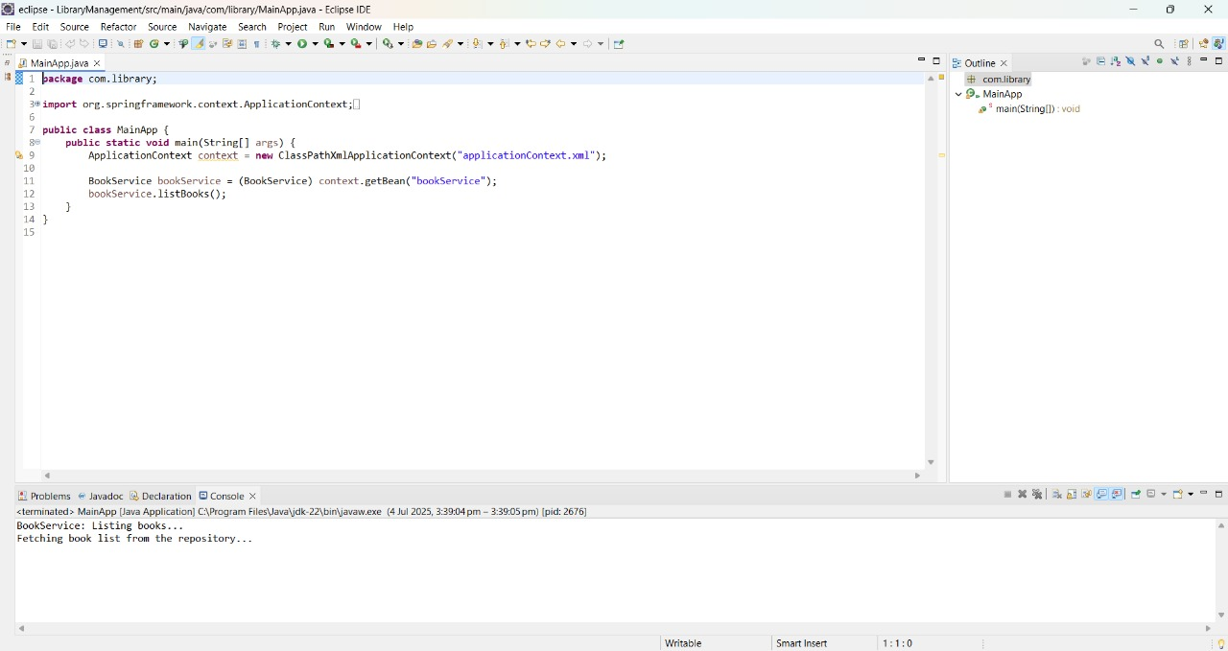

**Exercise 2: Implementing Dependency Injection**

**File Name : applicationContext.xml**

<?xml version="1.0" encoding="UTF-8"?>

<beans xmlns="http://www.springframework.org/schema/beans"

xmlns:xsi="http://www.w3.org/2001/XMLSchema-instance"

xsi:schemaLocation="

http://www.springframework.org/schema/beans

http://www.springframework.org/schema/beans/spring-beans.xsd">

<!-- BookRepository bean -->

<bean id="bookRepository" class="com.library.repository.BookRepository"/>

<!-- BookService bean with dependency injected -->

<bean id="bookService" class="com.library.service.BookService">

<property name="bookRepository" ref="bookRepository"/>

</bean>

</beans>

**File Name :** **BookService.java**

package com.library.service;

import com.library.repository.BookRepository;

public class BookService {

private BookRepository bookRepository;

// Setter required for setter-based DI

public void setBookRepository(BookRepository bookRepository) {

this.bookRepository = bookRepository;

}

public void addBook(String bookName) {

System.out.println("Adding book: " + bookName);

bookRepository.saveBook(bookName);

}

}

**File Name :LibraryApp.java**

package com.library.main;

import com.library.service.BookService;

import org.springframework.context.ApplicationContext;

import org.springframework.context.support.ClassPathXmlApplicationContext;

public class LibraryApp {

public static void main(String[] args) {

ApplicationContext context = new ClassPathXmlApplicationContext("applicationContext.xml");

BookService bookService = (BookService) context.getBean("bookService");

bookService.addBook("Clean Code");

}

}

**OUTPUT:**

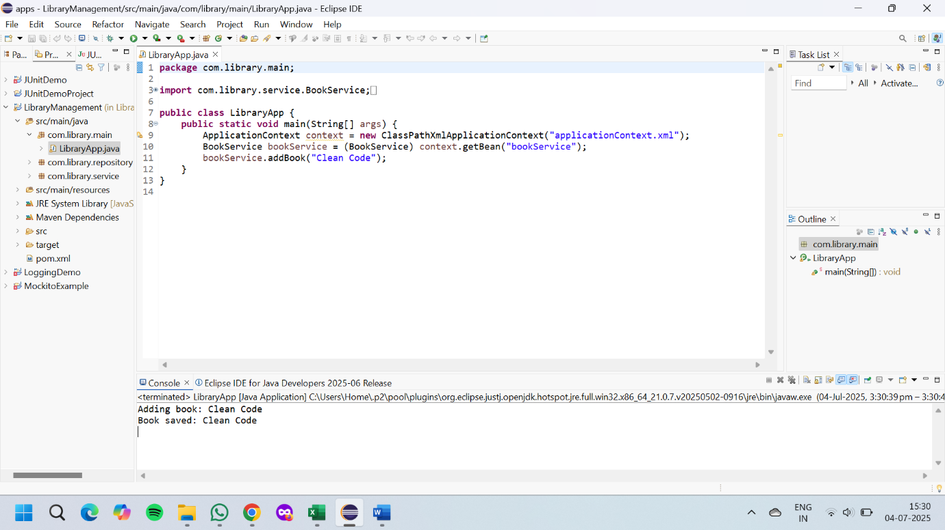

**Exercise 4: Creating and Configuring a Maven Project**

**File Name : pom.xml**

<project xmlns="http://maven.apache.org/POM/4.0.0"

xmlns:xsi="http://www.w3.org/2001/XMLSchema-instance"

xsi:schemaLocation="http://maven.apache.org/POM/4.0.0

http://maven.apache.org/xsd/maven-4.0.0.xsd">

<modelVersion>4.0.0</modelVersion>

<groupId>com.library</groupId>

<artifactId>LibraryManagement</artifactId>

<version>1.0-SNAPSHOT</version>

<dependencies>

<dependency>

<groupId>org.springframework</groupId>

<artifactId>spring-context</artifactId>

<version>5.3.36</version>

</dependency>

<dependency>

<groupId>org.springframework</groupId>

<artifactId>spring-aop</artifactId>

<version>5.3.36</version>

</dependency>

<dependency>

<groupId>org.springframework</groupId>

<artifactId>spring-webmvc</artifactId>

<version>5.3.36</version>

</dependency>

</dependencies>

<build>

<plugins>

<plugin>

<groupId>org.apache.maven.plugins</groupId>

<artifactId>maven-compiler-plugin</artifactId>

<version>3.10.1</version>

<configuration>

<source>1.8</source>

<target>1.8</target>

</configuration>

</plugin>

</plugins>

</build>

</project>

**File Name : applicationContext.xml**

<?xml version="1.0" encoding="UTF-8"?>

<beans xmlns="http://www.springframework.org/schema/beans"

xmlns:xsi="http://www.w3.org/2001/XMLSchema-instance"

xsi:schemaLocation="

http://www.springframework.org/schema/beans

http://www.springframework.org/schema/beans/spring-beans.xsd">

<!-- BookRepository Bean -->

<bean id="bookRepository" class="com.library.repository.BookRepository" />

<!-- BookService Bean -->

<bean id="bookService" class="com.library.service.BookService">

<property name="bookRepository" ref="bookRepository"/>

</bean>

</beans>

**File Name : BookRepository.java**

package com.library.repository;

public class BookRepository {

public void saveBook(String bookName) {

System.out.println("Book saved: " + bookName);

}

}

**File Name : BookService.java**

package com.library.service;

import com.library.repository.BookRepository;

public class BookService {

private BookRepository bookRepository;

// Setter-based injection

public void setBookRepository(BookRepository bookRepository) {

this.bookRepository = bookRepository;

}

public void addBook(String bookName) {

System.out.println("Adding book: " + bookName);

bookRepository.saveBook(bookName);

}

}

**File Name : LibraryApp.java**

package com.library.main;

import com.library.service.BookService;

import org.springframework.context.ApplicationContext;

import org.springframework.context.support.ClassPathXmlApplicationContext;

public class LibraryApp {

public static void main(String[] args) {

// Load Spring context

ApplicationContext context = new ClassPathXmlApplicationContext("applicationContext.xml");

// Get the BookService bean

BookService bookService = (BookService) context.getBean("bookService");

// Test it

bookService.addBook("The Lord of the Rings");

}

}

**OUTPUT:**

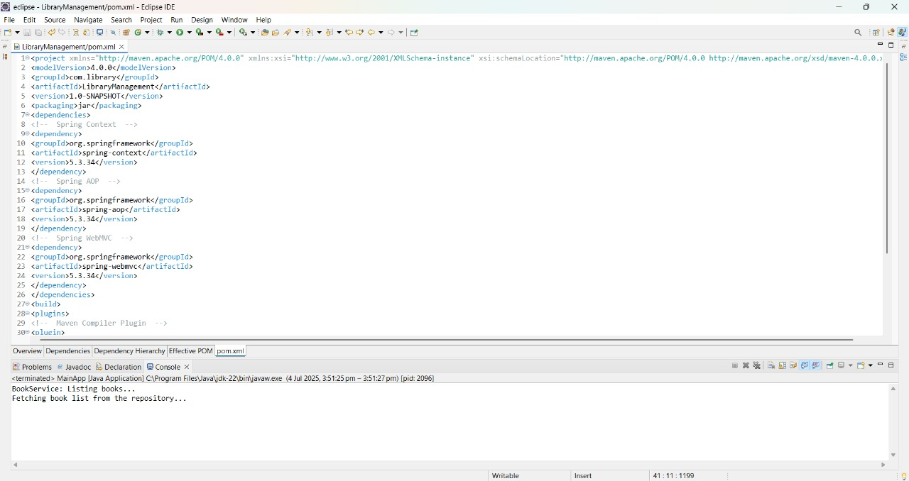

**1. spring-data-jpa-handson**

**Spring Data JPA - Quick Example**

**File Name : OrmLearnApplication.java**

package com.cognizant.ormlearn;

import java.util.List;

import org.slf4j.Logger;

import org.slf4j.LoggerFactory;

import org.springframework.boot.SpringApplication;

import org.springframework.boot.autoconfigure.SpringBootApplication;

import org.springframework.context.ApplicationContext;

import com.cognizant.ormlearn.model.Country;

import com.cognizant.ormlearn.service.CountryService;

@SpringBootApplication

public class OrmLearnApplication {

private static final Logger LOGGER = LoggerFactory.getLogger(OrmLearnApplication.class);

private static CountryService countryService;

public static void main(String[] args) {

ApplicationContext context = SpringApplication.run(OrmLearnApplication.class, args);

countryService = context.getBean(CountryService.class);

LOGGER.info("Inside main");

testGetAllCountries();

}

private static void testGetAllCountries() {

LOGGER.info("Start");

List<Country> countries = countryService.getAllCountries();

System.out.println("countries = " + countries); // Console Output

LOGGER.info("End");

}

}

**File Name :** **Country.java**

package com.cognizant.ormlearn.model;

import javax.persistence.Column;

import javax.persistence.Entity;

import javax.persistence.Id;

import javax.persistence.Table;

@Entity

@Table(name = "country")

public class Country {

@Id

@Column(name = "co_code")

private String code;

@Column(name = "co_name")

private String name;

public String getCode() {

return code;

}

public void setCode(String code) {

this.code = code;

}

public String getName() {

return name;

}

public void setName(String name) {

this.name = name;

}

@Override

public String toString() {

return "Country [code=" + code + ", name=" + name + "]";

}

}

**File Name :** **CountryRepository.java**

package com.cognizant.ormlearn.repository;

import org.springframework.data.jpa.repository.JpaRepository;

import org.springframework.stereotype.Repository;

import com.cognizant.ormlearn.model.Country;

@Repository

public interface CountryRepository extends JpaRepository<Country, String> {

}

**File Name : CountryService.java**

package com.cognizant.ormlearn.service;

import java.util.List;

import org.springframework.beans.factory.annotation.Autowired;

import org.springframework.stereotype.Service;

import org.springframework.transaction.annotation.Transactional;

import com.cognizant.ormlearn.model.Country;

import com.cognizant.ormlearn.repository.CountryRepository;

@Service

public class CountryService {

@Autowired

private CountryRepository countryRepository;

@Transactional

public List<Country> getAllCountries() {

return countryRepository.findAll();

}

}

**File Name : application.properties**

# Logging

logging.level.org.springframework=info

logging.level.com.cognizant=debug

logging.level.org.hibernate.SQL=trace

logging.level.org.hibernate.type.descriptor.sql=trace

logging.pattern.console=%d{dd-MM-yy} %d{HH:mm:ss.SSS} %-20.20thread %5p %-25.25logger{25} %25M %4L %m%n

# Database

spring.datasource.driver-class-name=com.mysql.cj.jdbc.Driver

spring.datasource.url=jdbc:mysql://localhost:3306/ormlearn

spring.datasource.username=root

spring.datasource.password=root

# Hibernate

spring.jpa.hibernate.ddl-auto=validate

spring.jpa.properties.hibernate.dialect=org.hibernate.dialect.MySQL5Dialect

**File Name :** **pom.xml**

<project xmlns="http://maven.apache.org/POM/4.0.0"

xmlns:xsi="http://www.w3.org/2001/XMLSchema-instance"

xsi:schemaLocation="http://maven.apache.org/POM/4.0.0

http://maven.apache.org/xsd/maven-4.0.0.xsd">

<modelVersion>4.0.0</modelVersion>

<groupId>com.cognizant</groupId>

<artifactId>orm-learn</artifactId>

<version>0.0.1-SNAPSHOT</version>

<packaging>jar</packaging>

<name>orm-learn</name>

<description>Demo project for Spring Data JPA and Hibernate</description>

<parent>

<groupId>org.springframework.boot</groupId>

<artifactId>spring-boot-starter-parent</artifactId>

<version>2.7.0</version>

<relativePath/>

</parent>

<properties>

<java.version>11</java.version>

</properties>

<dependencies>

<dependency>

<groupId>org.springframework.boot</groupId>

<artifactId>spring-boot-starter-data-jpa</artifactId>

</dependency>

<dependency>

<groupId>mysql</groupId>

<artifactId>mysql-connector-java</artifactId>

<scope>runtime</scope>

</dependency>

<dependency>

<groupId>org.springframework.boot</groupId>

<artifactId>spring-boot-devtools</artifactId>

<scope>runtime</scope>

</dependency>

<dependency>

<groupId>org.springframework.boot</groupId>

<artifactId>spring-boot-starter-test</artifactId>

<scope>test</scope>

</dependency>

</dependencies>

<build>

<plugins>

<plugin>

<groupId>org.springframework.boot</groupId>

<artifactId>spring-boot-maven-plugin</artifactId>

</plugin>

</plugins>

</build>

</project>

**OUTPUT:**

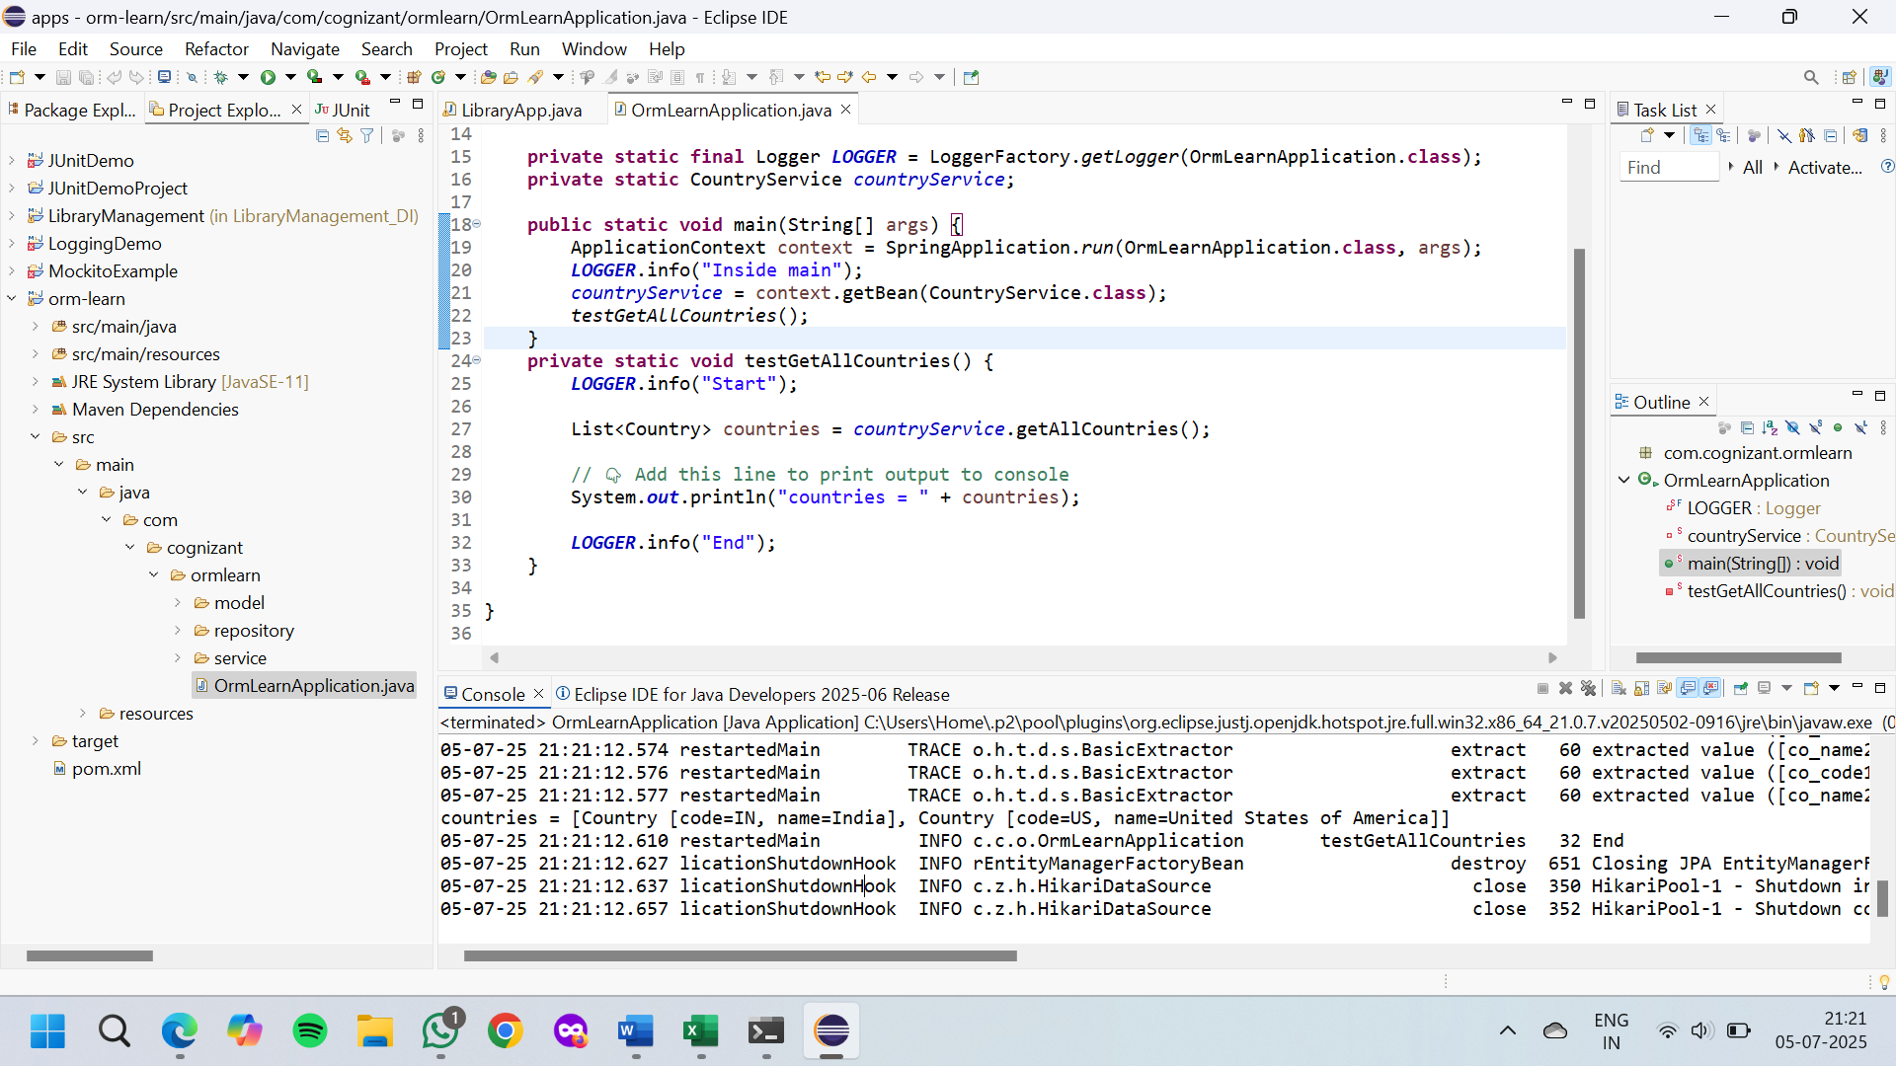

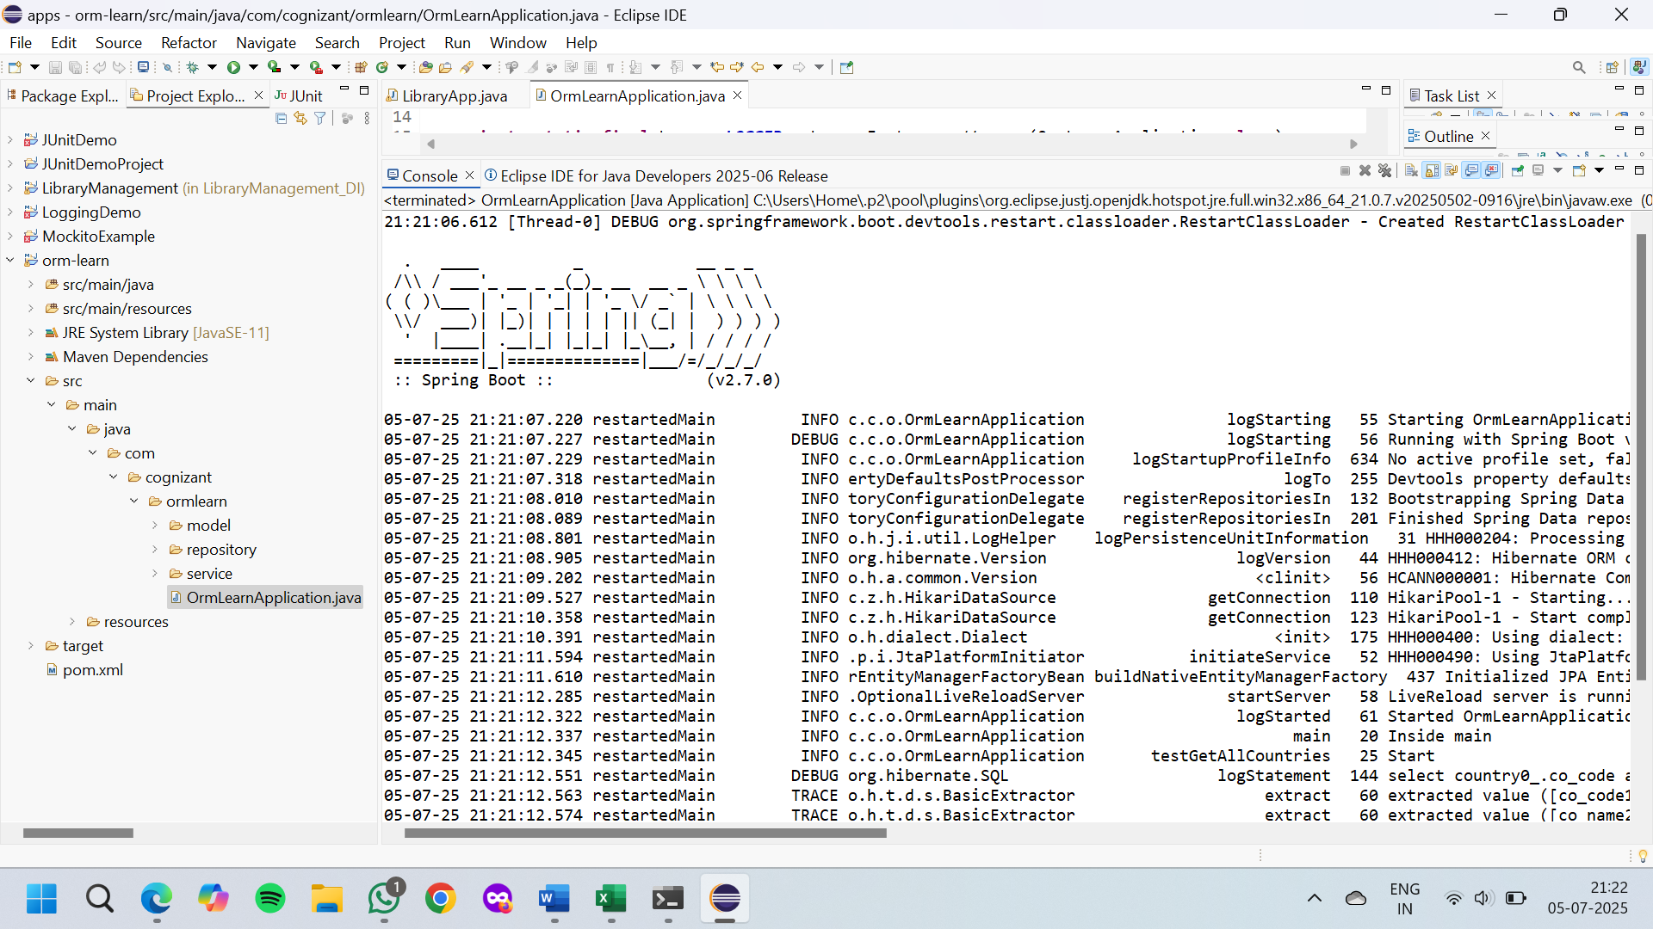

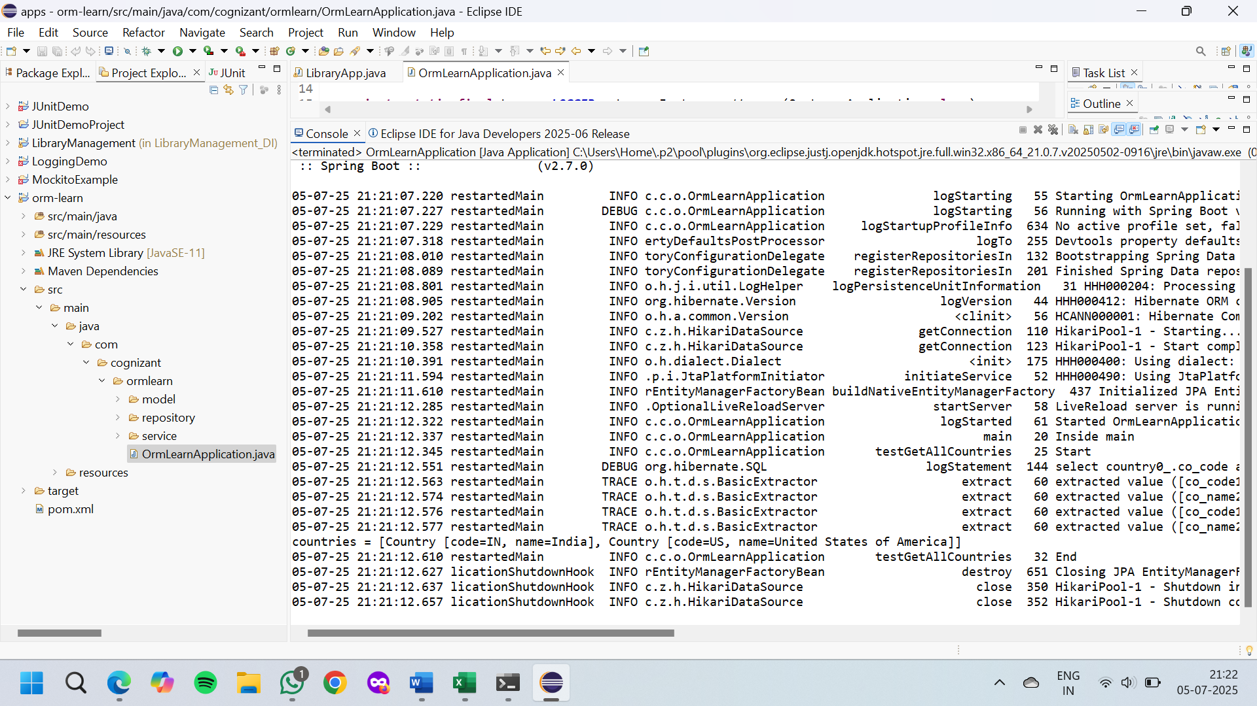

**Difference between JPA, Hibernate and Spring Data JPA**

**Hibernate Example**

**File Name : pom.xml**

<project xmlns=”http://maven.apache.org/POM/4.0.0”>

<modelVersion>4.0.0</modelVersion>

<groupId>com.example</groupId>

<artifactId>HibernateExample</artifactId>

<version>1.0</version>

<dependencies>

<dependency>

<groupId>org.hibernate</groupId>

<artifactId>hibernate-core</artifactId>

<version>5.6.15.Final</version>

</dependency>

<dependency>

<groupId>mysql</groupId>

<artifactId>mysql-connector-java</artifactId>

<version>8.0.30</version>

</dependency>

</dependencies>

</project>

**File Name : hibernate.cfg.xml**

<!DOCTYPE hibernate-configuration PUBLIC

"-//Hibernate/Hibernate Configuration DTD 3.0//EN"

"http://hibernate.sourceforge.net/hibernate-configuration-3.0.dtd">

<hibernate-configuration>

<session-factory>

<property name="hibernate.connection.driver_class">com.mysql.cj.jdbc.Driver</property>

<property name="hibernate.connection.url">jdbc:mysql://localhost:3306/testdb</property>

<property name="hibernate.connection.username">root</property>

<property name="hibernate.connection.password">root</property>

<property name="hibernate.dialect">org.hibernate.dialect.MySQL8Dialect</property>

<property name="hibernate.hbm2ddl.auto">update</property>

<mapping class="com.example.Employee"/>

</session-factory>

</hibernate-configuration>

**File Name : Employee.java**

package com.example;

import javax.persistence.*;

@Entity

@Table(name = "employee")

public class Employee {

@Id

@GeneratedValue(strategy = GenerationType.IDENTITY)

private int id;

private String name;

private String department;

// Getters and setters

public int getId() { return id; }

public void setId(int id) { this.id = id; }

public String getName() { return name; }

public void setName(String name) { this.name = name; }

public String getDepartment() { return department; }

public void setDepartment(String department) { this.department = department; }

}

**File Name : MainApp.java**

package com.example;

import org.hibernate.*;

import org.hibernate.cfg.Configuration;

public class MainApp {

public static void main(String[] args) {

SessionFactory factory = new Configuration().configure().buildSessionFactory();

Session session = factory.openSession();

Transaction tx = null;

try {

tx = session.beginTransaction();

Employee emp = new Employee();

emp.setName("John");

emp.setDepartment("IT");

session.save(emp);

tx.commit();

System.out.println("Employee saved with ID: " + emp.getId());

} catch (Exception e) {

if (tx != null) tx.rollback();

e.printStackTrace();

} finally {

session.close();

factory.close();

}

}

}

**OUTPUT:**

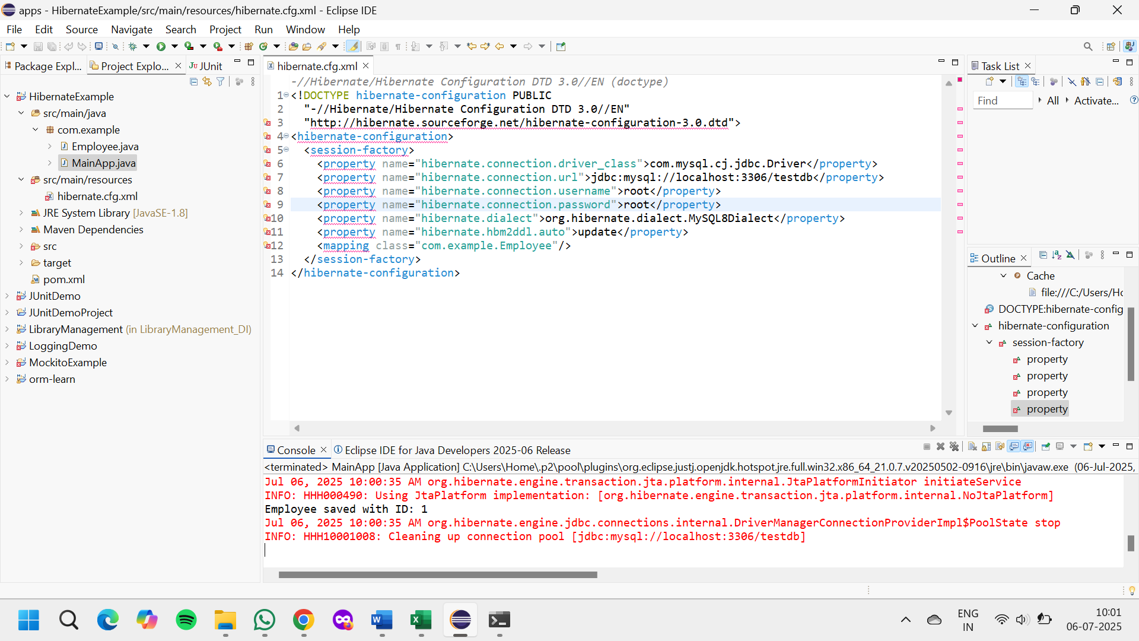

**Spring Data JPA Example**

**File Name : pom.xml**

<project xmlns="http://maven.apache.org/POM/4.0.0">

<modelVersion>4.0.0</modelVersion>

<groupId>com.example</groupId>

<artifactId>SpringDataJPAExample</artifactId>

<version>1.0</version>

<parent>

<groupId>org.springframework.boot</groupId>

<artifactId>spring-boot-starter-parent</artifactId>

<version>2.7.15</version>

</parent>

<dependencies>

<dependency>

<groupId>org.springframework.boot</groupId>

<artifactId>spring-boot-starter-data-jpa</artifactId>

</dependency>

<dependency>

<groupId>mysql</groupId>

<artifactId>mysql-connector-java</artifactId>

<version>8.0.30</version>

</dependency>

</dependencies>

</project>

**File Name : application.properties**

spring.datasource.url=jdbc:mysql://localhost:3306/testdb

spring.datasource.username=root

spring.datasource.password=root

spring.jpa.hibernate.ddl-auto=update

**File Name : Employee.java**

package com.example.entity;

import javax.persistence.*;

@Entity

public class Employee {

@Id

@GeneratedValue(strategy = GenerationType.IDENTITY)

private int id;

private String name;

private String department;

// Getters and setters

public int getId() { return id; }

public void setId(int id) { this.id = id; }

public String getName() { return name; }

public void setName(String name) { this.name = name; }

public String getDepartment() { return department; }

public void setDepartment(String department) { this.department = department; }

}

**File Name : EmployeeRepository.java**

package com.example.repository;

import com.example.entity.Employee;

import org.springframework.data.jpa.repository.JpaRepository;

public interface EmployeeRepository extends JpaRepository<Employee, Integer> {

}

**File Name : EmployeeService.java**

package com.example.service;

import com.example.entity.Employee;

import com.example.repository.EmployeeRepository;

import org.springframework.beans.factory.annotation.Autowired;

import org.springframework.stereotype.Service;

import javax.transaction.Transactional;

@Service

public class EmployeeService {

@Autowired

private EmployeeRepository employeeRepository;

@Transactional

public void addEmployee(Employee emp) {

employeeRepository.save(emp);

}

}

**File Name : SpringDataJpaApp.java**

package com.example;

import com.example.entity.Employee;

import com.example.service.EmployeeService;

import org.springframework.beans.factory.annotation.Autowired;

import org.springframework.boot.CommandLineRunner;

import org.springframework.boot.SpringApplication;

import org.springframework.boot.autoconfigure.SpringBootApplication;

@SpringBootApplication

public class SpringDataJpaApp implements CommandLineRunner {

@Autowired

private EmployeeService employeeService;

public static void main(String[] args) {

SpringApplication.run(SpringDataJpaApp.class, args);

}

@Override

public void run(String... args) {

Employee emp = new Employee();

emp.setName("Alice");

emp.setDepartment("HR");

employeeService.addEmployee(emp);

System.out.println("Employee added via Spring Data JPA");

}

}

**OUTPUT:**

